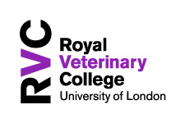

Application for approval of Social media account.
Name of applicant | Department | Need for Social media account: Why do you think having a separate social media account is necessary, what are your objectives in having your own social media profile and how do you intend to report on its success?
Name of team member to manage account and be main point of contact. Please provide email and phone contact details. | Department | Names of other team members who require access to the accounts(s) | Comments
How do you propose to promote your social media profile?
How do you propose to connect your content and or posts to main RVC profile
Do you require training (delete as appropriate) | Yes  No
Proposed frequency of posts: please enter minimum number | Daily  Weekly  Monthly
Admin logins for the account. | Username  Password

If approved all new accounts must abide by the RVC social media policy and will to be added to the list of approved social media accounts.

All social media accounts will be kept under review. If after 6 months the expected level of posts, engagement and new follower growth has not been achieved then Marketing will arrange meeting with account holder to discuss how content can be more effectively shared via main or alternative channels.
Name and signature of Line manager who has approved this application:

Date:
Please email this application to: marketing@rvc.ac.uk

